SYSTEM ADMIN WITH IT SERVICE MANAGEMENT
& AI EMPHASIS
YEAR : 3RD YEAR
COLLEGE CODE : MSU220
COLLEGE NAME : SRI SANKARA BHAGAVTHI ARTS AND SCIENCE COLLEGE, KOMMADIMOTTAI
DEPARTMENT : BCA
SEMESTER : 5
TITLE : IMPLEMENT CLIENT SCRIPT & UI POLICY (INCIDENT)
GOOGLE DRIVE LINK:
https://drive.google.com/file/d/1pWvA9scICC7YBoPaz-YAhvhrQJc7JweU/view?usp=drive_link
GITHUB LINK :
https://github.com/Saravanan-30/Naan_Mudhalvan.git

TEAM DETAILS :
Team Member 1
Name : Muthu Saravanan L
Register No: 24082200500111103
NM ID : C44EF1B27EDBBAC914542E078D25E22C
MAIL ID : muthusaravanan130@gmail.com
Team Member 2
Name : Muthu Maharajan T
Register No: 24082200500111104
NM ID : 117181B6B313F4BABA34BF70A2A5D9AD
MAIL ID : muthurajesh112007@gmail.com

Team Member 3
Name : Sivaraj S
Register No: 24082200500111105
NM ID : 7FCC7930E03B6659A454FA410FFE8F50
MAIL ID : svsivaraj921@gmail.com

Team Size: 3 Members

ABSTRACT
The project “Implement Client Script & UI Policy (Incident)” focuses on improving data accuracy in ServiceNow Incident Management. UI Policies and Client Scripts are used to control field behaviour, automatically update values, validate user inputs, and prevent incorrect Incident updates. The project is tested through different Incident scenarios to ensure proper functionality. Overall, it helps reduce data entry errors and maintain consistent Incident records.

1. INTRODUCTION
ServiceNow Incident Management helps organizations manage and resolve incidents efficiently. However, incorrect or incomplete data entry can affect the incident handling process.
This project implements UI Policies and Client Scripts on the Incident table to control field behaviour, automatically update values, validate user inputs, and prevent incorrect updates. The project demonstrates how these features can improve data accuracy and provide a consistent Incident Management process.

2. BRAINSTORMING & IDEATION PHASE

2.1 Problem Identification
In ServiceNow Incident Management, users may enter incomplete, inconsistent, or incorrect information while creating or updating Incident records. Manual checking of every field can also lead to errors and affect the incident management process. Therefore, a controlled method is required to validate information and dynamically manage Incident fields based on specific conditions.

2.2 Project Idea
The project idea is to implement UI Policies and Client Scripts in the ServiceNow Incident table. These features are used to dynamically control fields, automatically set values, validate user input, and restrict unwanted changes.

2.3 Proposed Solution
The proposed solution is to configure the Incident form with appropriate UI Policies and Client Scripts. When an Incident has High Impact, the system applies the required field controls and validations automatically. This helps users enter correct information and reduces errors during Incident creation and updating.

2.4 Objective
The main objectives of the project are:
- To improve data accuracy in Incident records.
- To control field behaviour dynamically.
- To automatically update required values.
- To validate Incident records before submission.
- To prevent unwanted changes through list editing.

3. REQUIREMENT ANALYSIS PHASE

3.1 Functional Requirements
The project should provide the following functionalities:
- Create a UI Policy for High Impact Incidents.
- Make Assignment Group mandatory when Impact is High.
- Make the Urgency field read-only when Impact is High.
- Automatically set Urgency to High when Impact is High.
- Prevent saving when Assigned To is empty for High Impact incidents.
- Prevent State changes through direct list editing.
- Allow State changes through the Incident form.
- Reverse the UI Policy Behaviour when Impact is changed from High to another value.

3.2 Software Requirements
The following software and platform are required:
- ServiceNow Personal Developer Instance (PDI)
- Web Browser
- ServiceNow Incident Management
- UI Policy
- UI Policy Actions
- Client Scripts

3.3 Skills Required
The project requires basic knowledge of:
- ServiceNow Incident Management
- UI Policies
- UI Policy Actions
- Client Scripts
- Basic JavaScript
- Form Validation

4. PROJECT DESIGN PHASE

4.1 System Design
The project is designed to control the behaviour of Incident records based on the values entered by the user. UI Policies and Client Scripts work together to provide dynamic field control and validation.
The basic workflow is:
Incident Form → Impact = High → UI Policy / Client Script → Field Behaviour & Validation → Record Submission

4.2 UI Policy Design
A UI Policy named High Impact Control is created for the Incident table.
The condition is set to Impact is 1 – High. When this condition is satisfied, the Assignment Group field becomes mandatory. The Reverse if false option is enabled to restore the normal Behaviour when the condition is no longer true.

4.3 UI Policy Action Design
A UI Policy Action is configured for the Urgency field. When the Impact is High, the Urgency field becomes read-only.

4.4 Client Script Design
Three Client Scripts are designed for different purposes:
onChange: Automatically sets Urgency to High when Impact is High.
onSubmit: Prevents saving when Assigned To is empty for a High Impact Incident.
onCellEdit: Prevents State changes through direct list editing.

4.5 Overall Workflow
Impact = High
↓
Assignment Group → Mandatory
↓
Urgency → Read-only & Automatically set to High
↓
Assigned To → Required before saving
↓
State → Cannot be changed through list editing

5. PROJECT PLANNING PHASE

5.1 Development Plan
The project was planned in a step-by-step manner to ensure that all required UI Policies and Client Scripts were implemented and tested properly.
The development process was divided into five main tasks followed by functional testing.

5.2 Task Planning
Task 1 – UI Policy Creation
Create the High Impact Control UI Policy for the Incident table and configure the High Impact condition.
Task 2 – UI Policy Action
Configure the Urgency UI Policy Action to make the field read-only when Impact is High.
Task 3 – onChange Client Script
Create a Client Script to automatically set Urgency to High when Impact changes to High.
Task 4 – onSubmit Client Script
Create a Client Script to prevent submission when Assigned To is empty for a High Impact Incident.
Task 5 – onCellEdit Client Script
Create a Client Script to prevent direct State changes through Incident list editing.

5.3 Testing Plan
After completing the development tasks, the project was tested using different Incident scenarios.
The testing includes:
- High Impact Incident validation.
- Successful Incident submission.
- Reverse condition testing.
- State list-edit restriction.
- State form-based update.

5.4 Project Execution Flow
Planning
↓
UI Policy Configuration
↓
Client Script Configuration
↓
Functional Testing
↓
Result Verification
↓
Final Demonstration

5.5 Expected Outcome
The planned implementation is expected to provide proper field validation, automatic value updates, controlled field Behaviour, and prevention of unwanted Incident modifications.

6. PROJECT DEVELOPMENT PHASE

6.1 Task 1 – Create UI Policy
A UI Policy named High Impact Control was created for the Incident table.The condition was configured as Impact is 1 – High. The policy was activated and the Reverse if false option was enabled. The Assignment Group field was configured as mandatory for High Impact incidents.

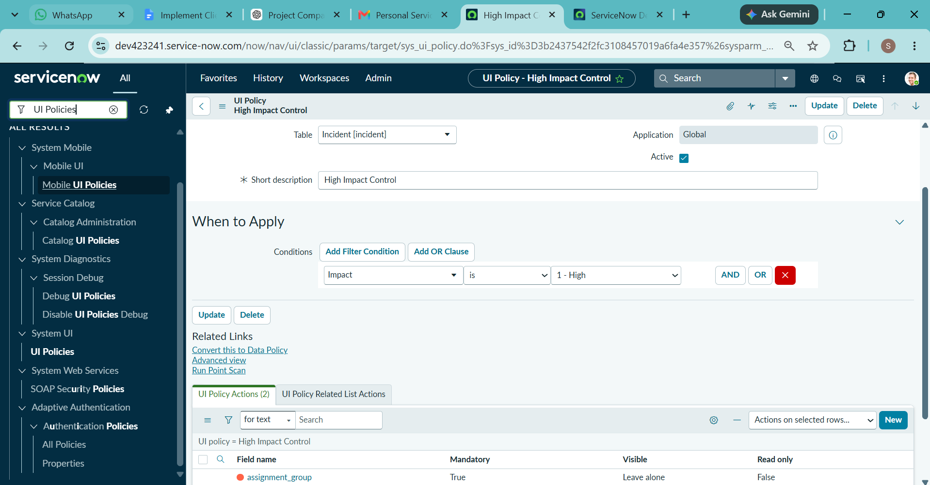
Figure 1: High Impact Control UI Policy

6.2 Task 2 – Configure UI Policy Action
A UI Policy Action was created under the High Impact Control policy for the Urgency field.
The Read-only option was enabled. Therefore, when the Impact is High, the Urgency field cannot be manually modified.
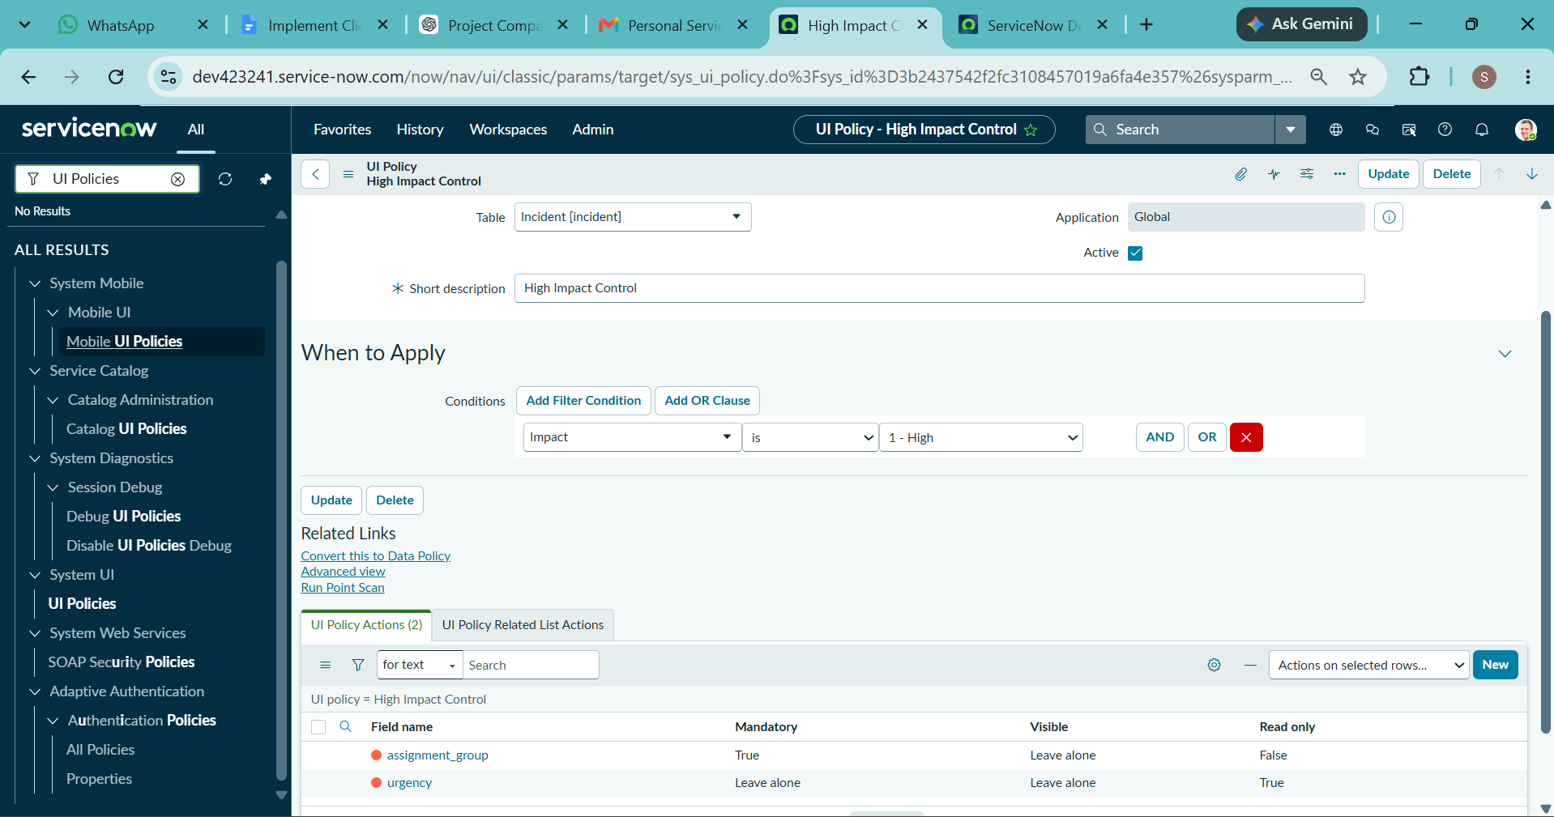
Figure 2: Urgency UI Policy Action

6.3 Task 3 – Create onChange Client Script
An onChange Client Script named Auto set urgency for high impact was created for the Incident table.
The script is triggered when the Impact field is changed. When the Impact is set to High, the system automatically sets the Urgency to High and displays an information message.
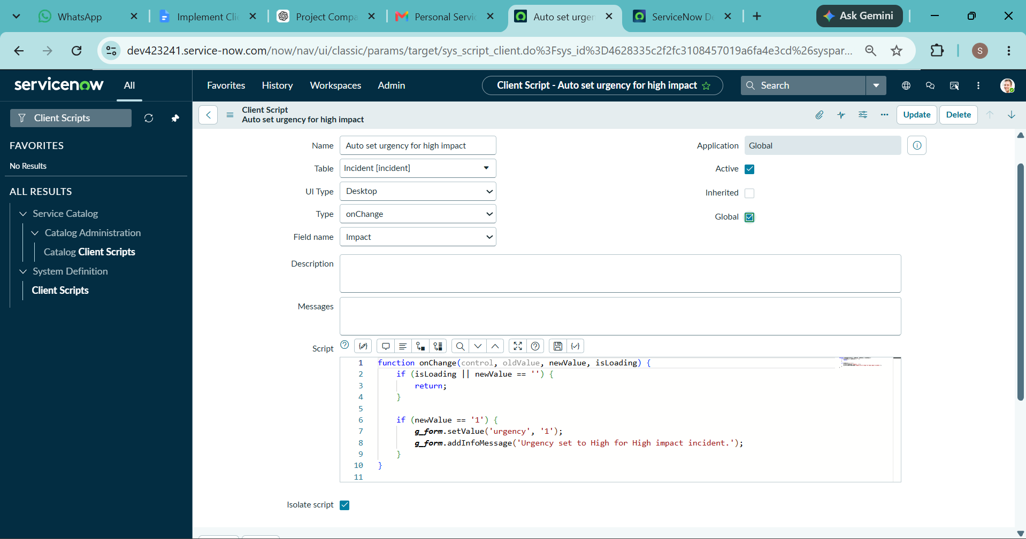
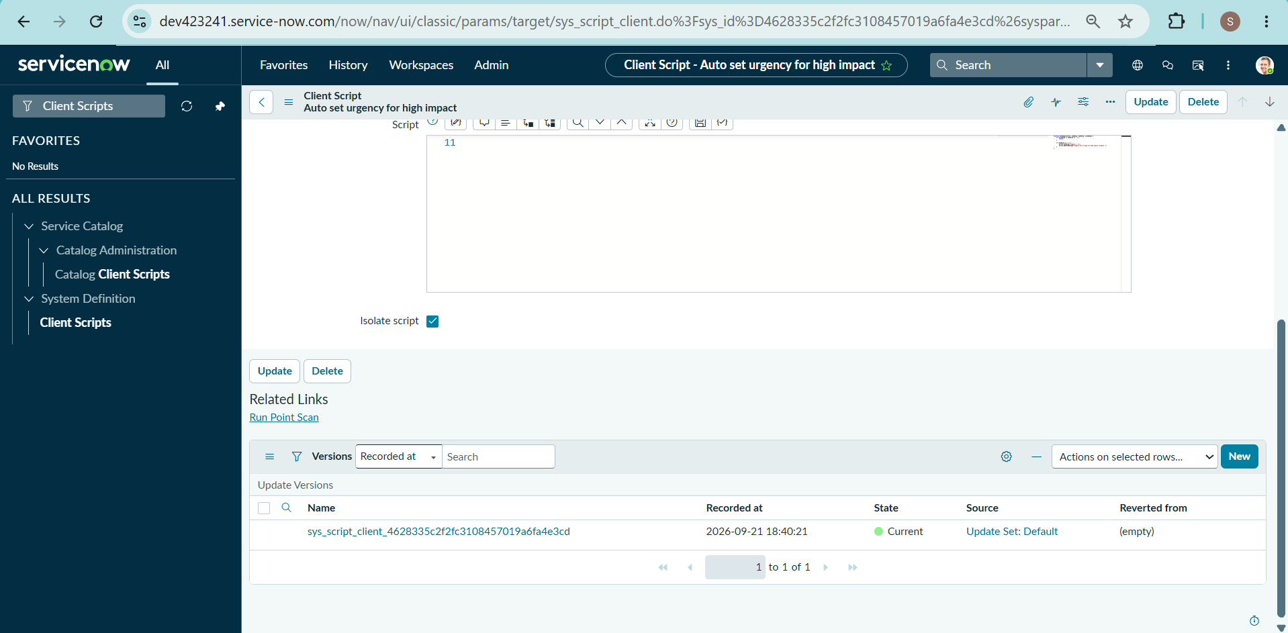
Figure 3: Auto Set Urgency Client Script

Task 3 – Working Result
When Impact was changed to High, the Urgency field was automatically updated to High.
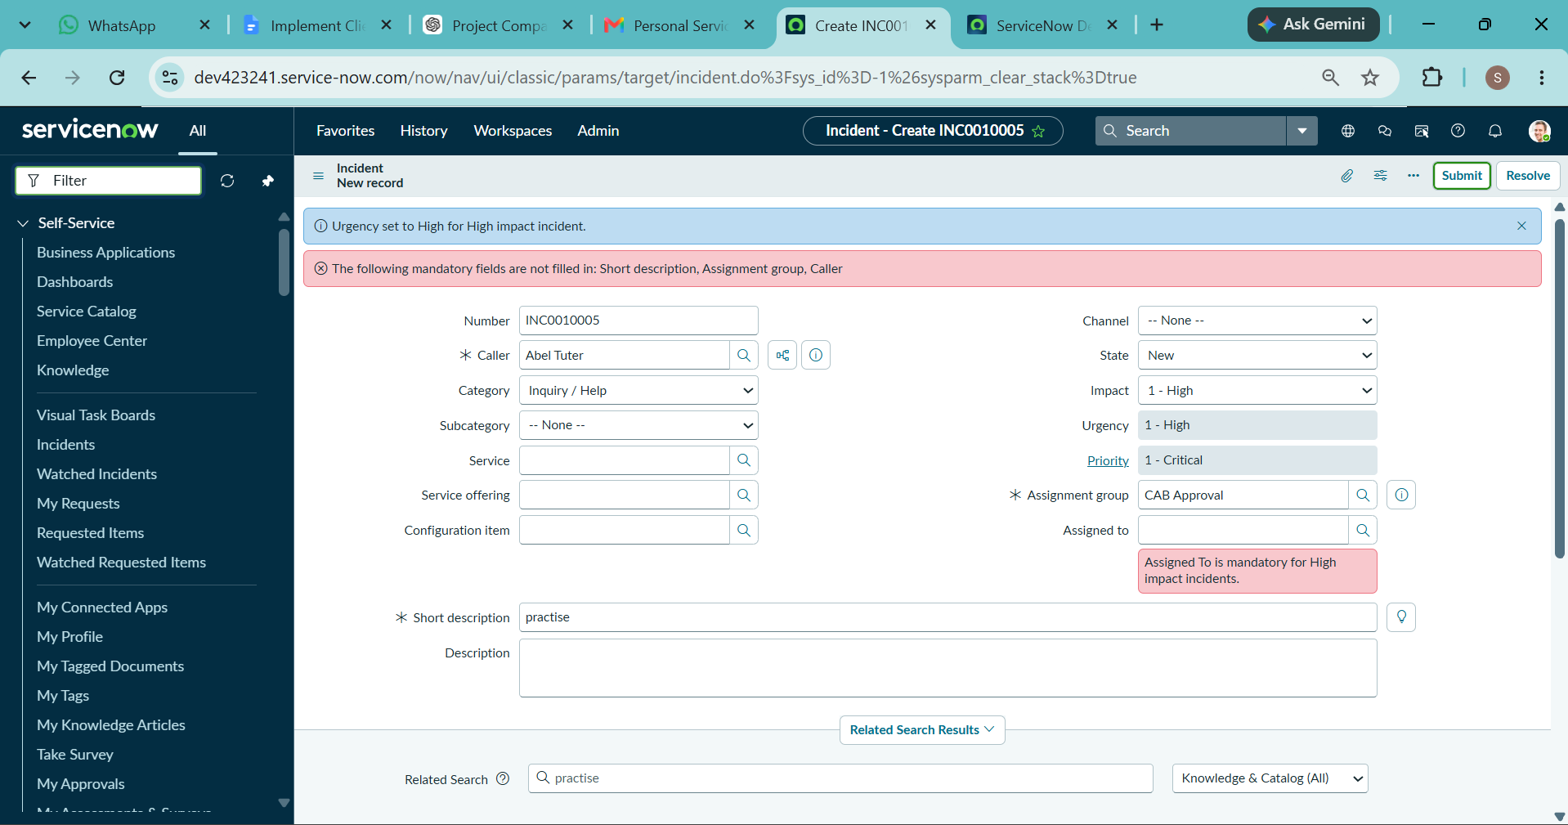
Figure 4: Automatic Urgency Update

6.4 Task 4 – Create onSubmit Client Script
An onSubmit Client Script named Prevent save if Assigned To missing was created for the Incident table.The script checks whether the Impact is High and whether the Assigned To field is empty. If both conditions are satisfied, the system prevents the Incident from being saved and displays an error message.
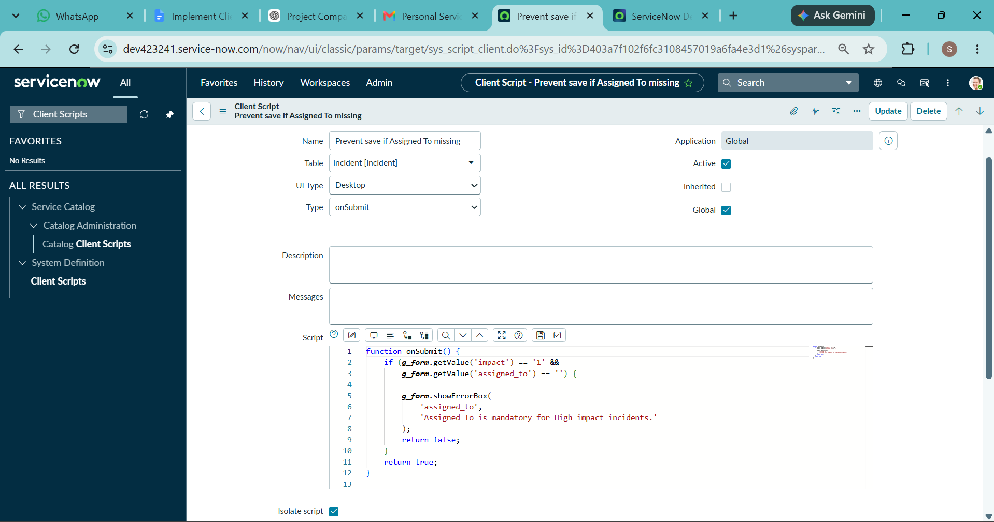
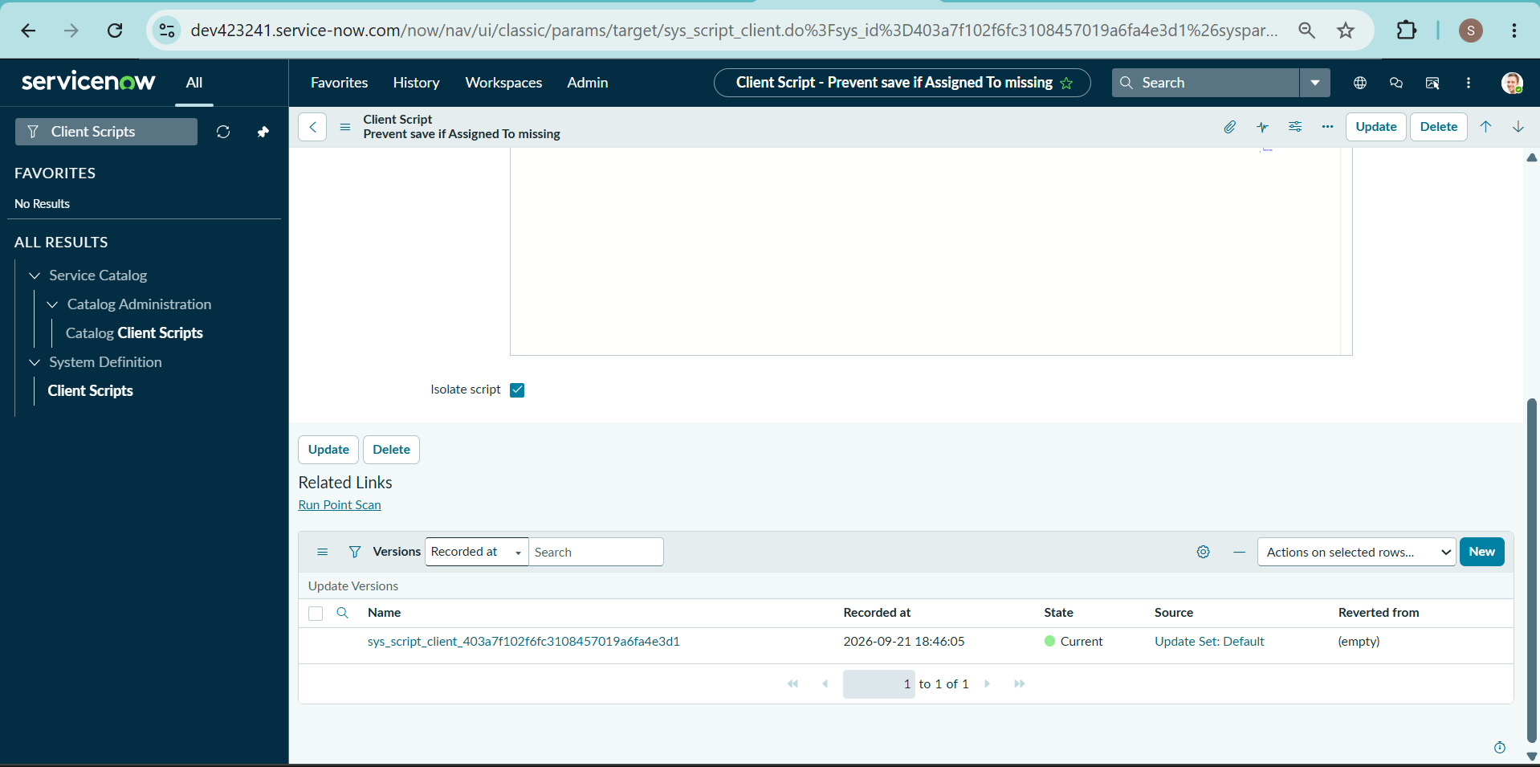
Figure 5: Prevent Save Client Script

Task 4 – Working Result
When Impact was High and Assigned To was empty, the system prevented the Incident from being submitted.
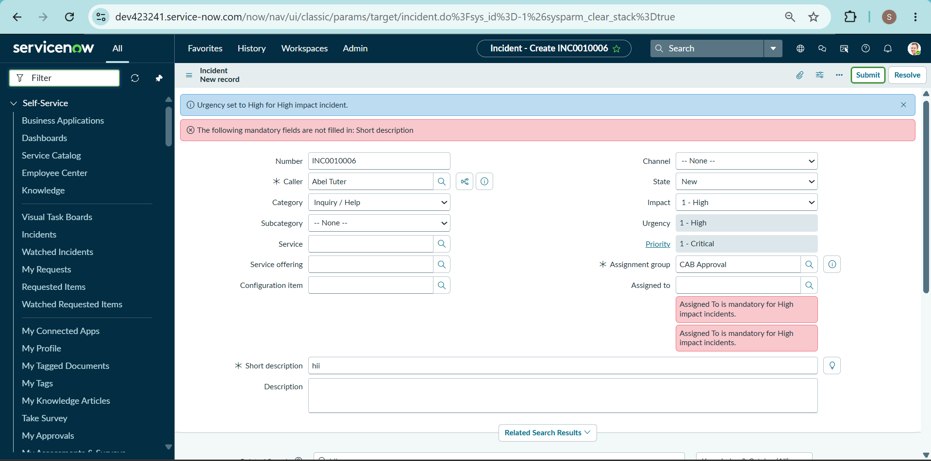
Figure 6: Assigned To Validation

6.5 Task 5 – Create onCellEdit Client Script
An onCellEdit Client Script named Prevent state change via list edit was created for the State field.
The script prevents users from directly changing the Incident State through list editing and displays an alert instructing the user to open the Incident form.
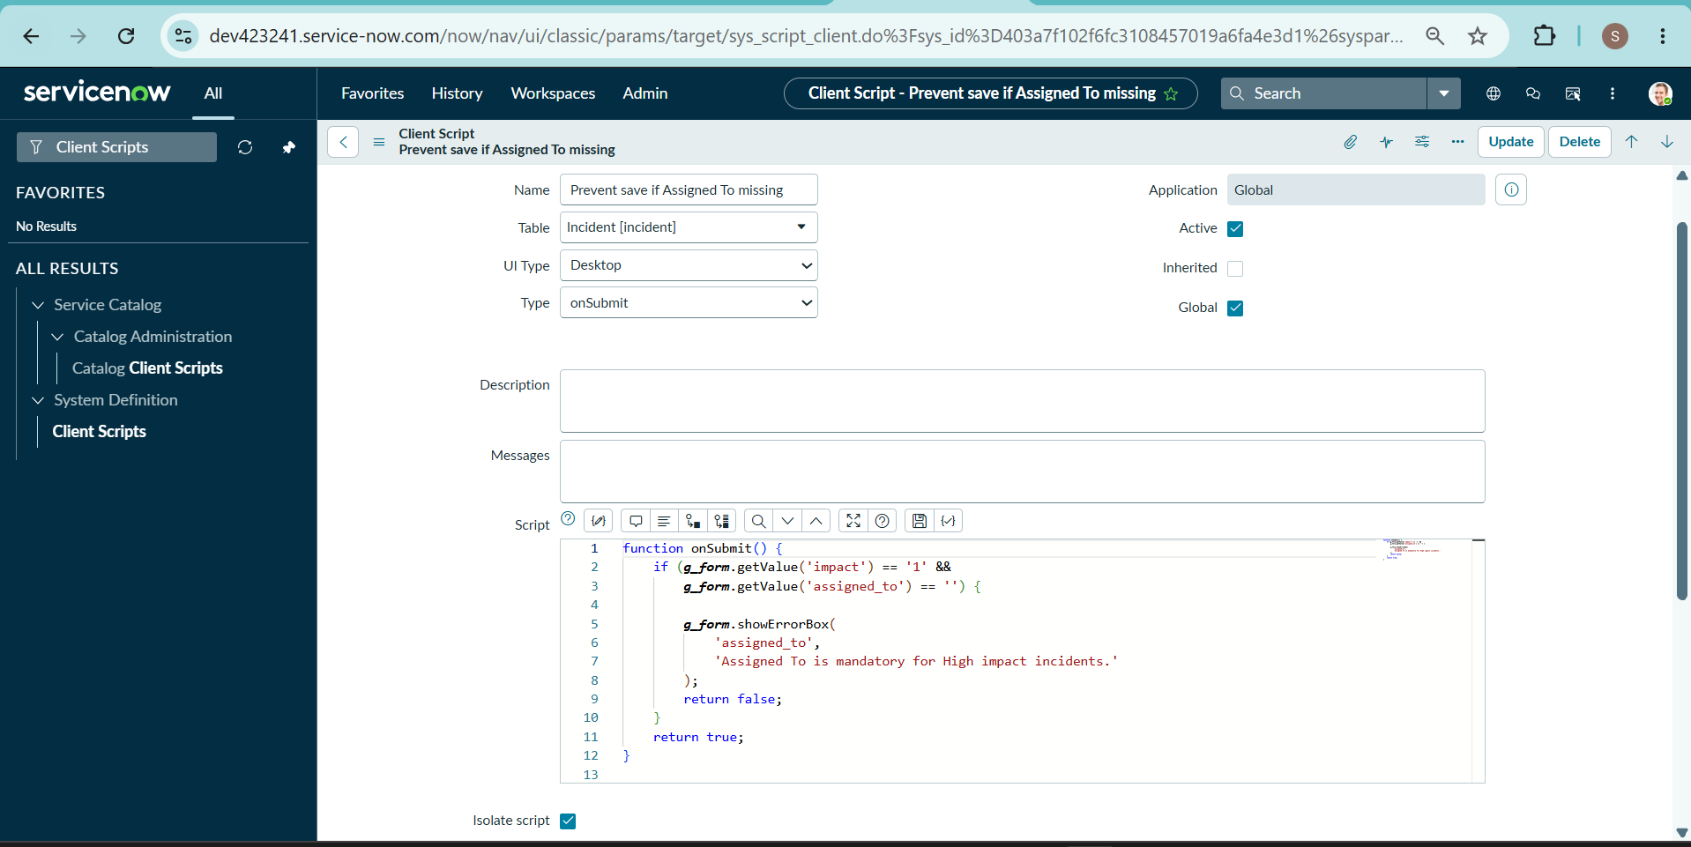
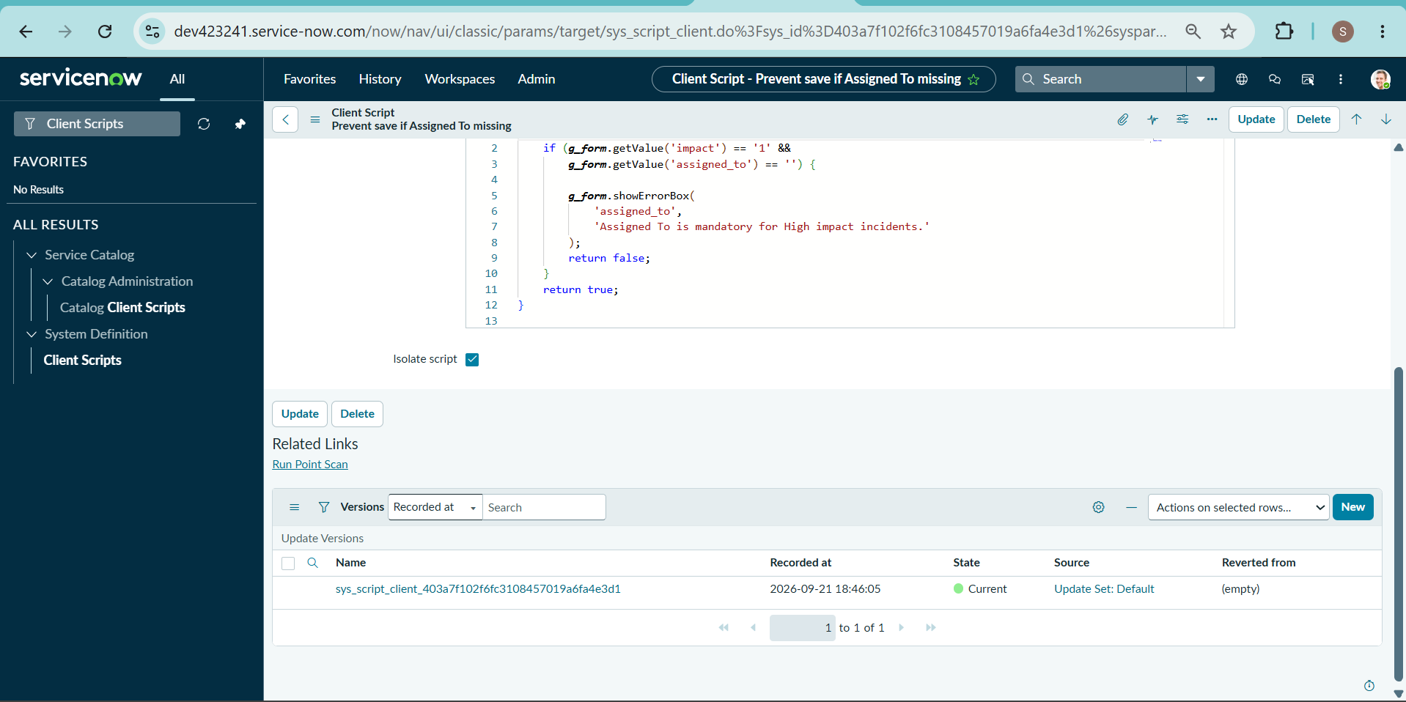
Figure 7: Prevent State Change Client Script

Task 5 – Working Result
When the State was edited directly from the Incident list, an alert message was displayed and the State change was blocked.
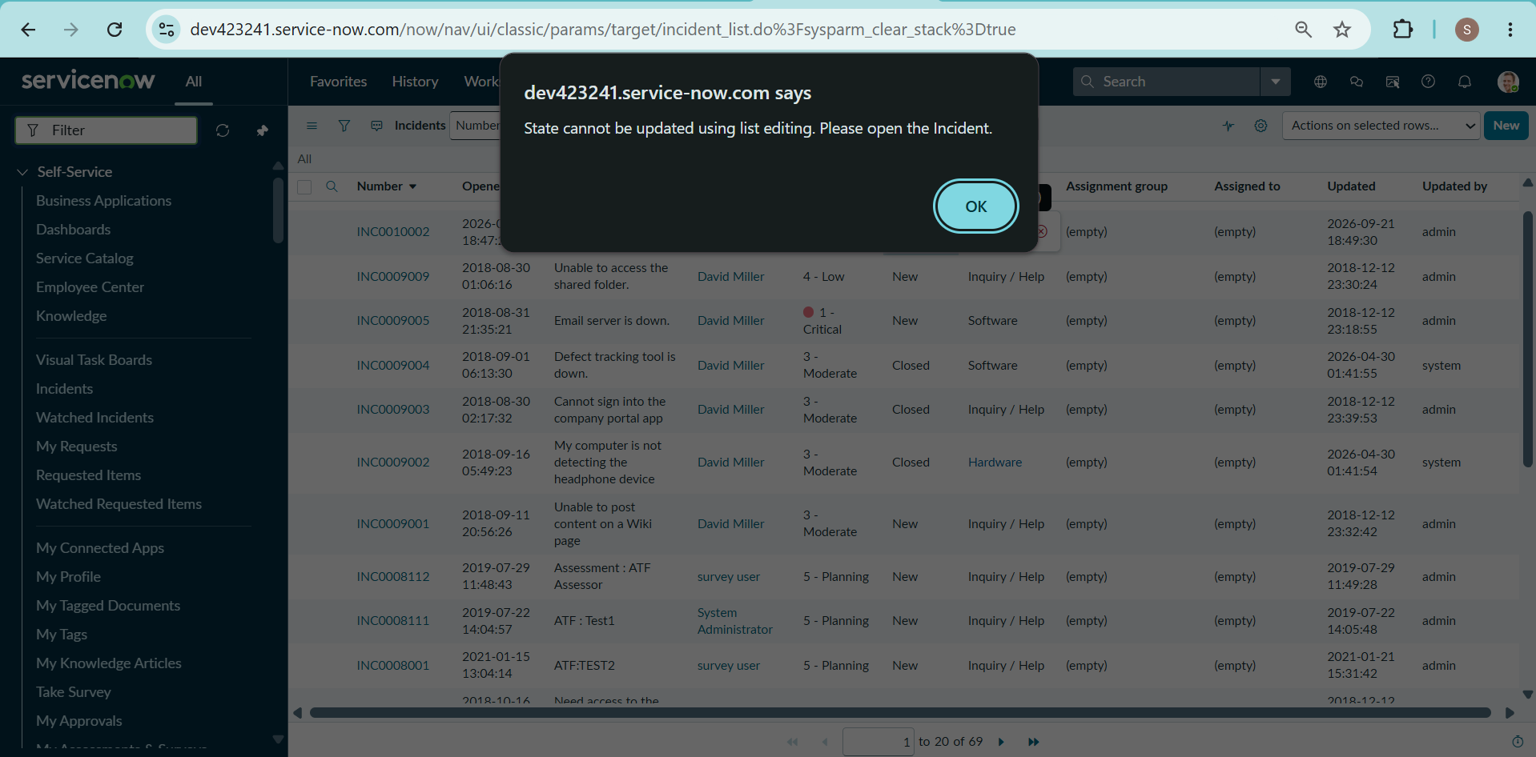
Figure 8: State List Edit Restriction

7. PROJECT TESTING PHASE

7.1 Activity 1 – Create New Incident
A new Incident was created and the Impact was set to 1 – High while Assigned To was left empty. When Submit was selected, the system prevented the Incident from being saved and displayed the validation message.
Expected Result:
The Incident should not be saved when Assigned To is empty for a High Impact Incident. The UI Policy and Urgency Behaviour should also work correctly.
Actual Result:
The validation worked successfully and the Incident was not submitted without the required information.
Screenshot:
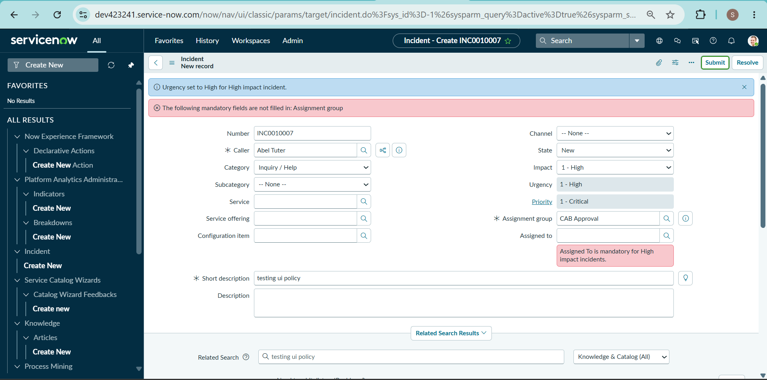

7.2 Activity 2 – Successful Incident Submission
The Assigned To field was filled and the Incident was submitted again. The Incident was saved successfully. The automatic Urgency setting and other field restrictions were also verified.
Expected Result:
The Incident should be saved successfully after providing the required information.
Actual Result:
The Incident was saved successfully and the configured rules worked as expected.
Screenshot:
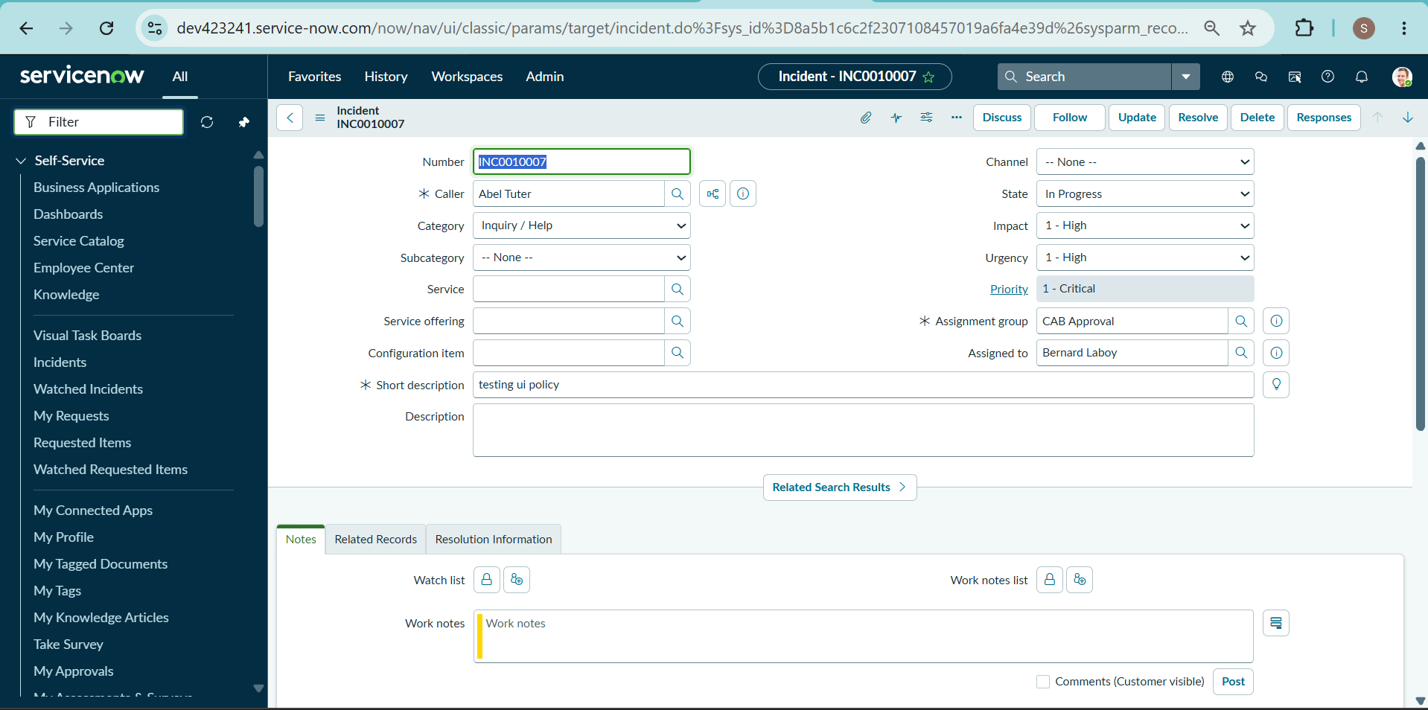

7.3 Activity 3 – Reverse Condition Test
An existing Incident INC0010003 was opened with Impact set to High. The Impact was changed from High to Medium.
Expected Result:
When Impact is changed from High to another value, Assigned To should no longer be mandatory and Urgency should become editable. The Incident should be saved successfully.
Actual Result:
The reverse condition worked successfully. Assigned To was no longer mandatory, Urgency became editable, and the Incident was saved.
Screenshot:
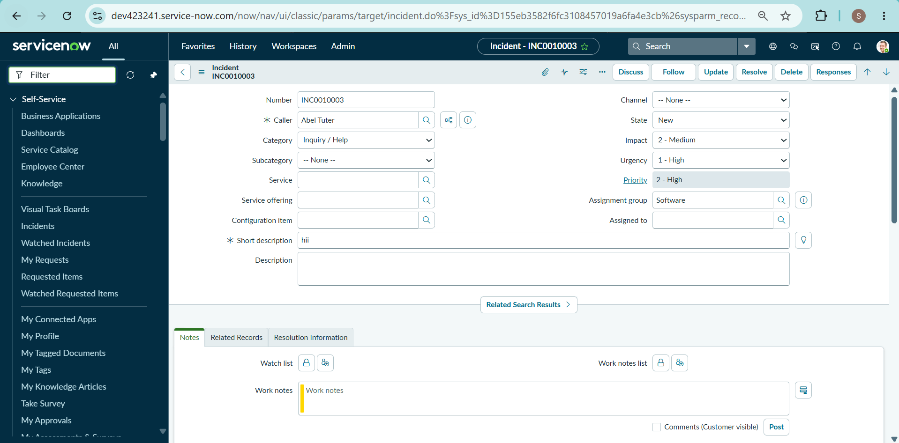

7.4 Activity 4 – State Change Through List Editing
The Incident list was opened through Incident → All. The State field was double-clicked to perform a direct list edit.
Expected Result:
Direct State changes through list editing should be blocked and an alert message should be displayed.
Actual Result:
The alert message was displayed and the State value remained unchanged.
Screenshot:
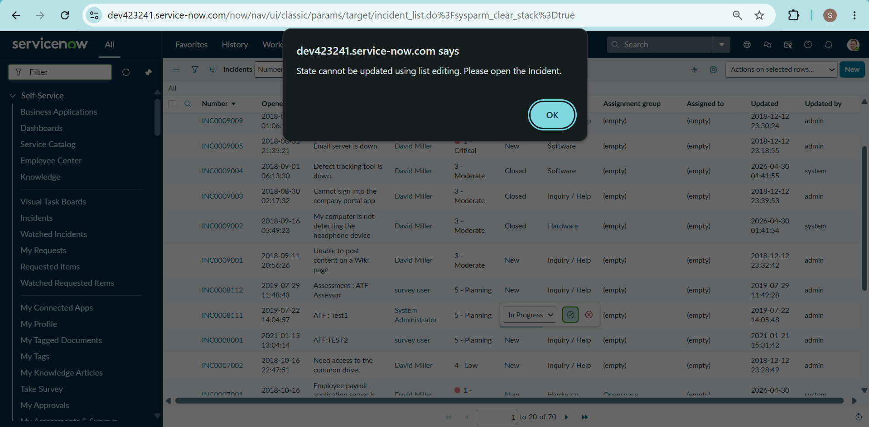

7.5 Activity 5 – State Change Through Incident Form
The same Incident was opened from the Incident form. The State value was changed and the record was updated.
Expected Result:
State changes made through the Incident form should be saved successfully.
Actual Result:
The State change was saved successfully through the Incident form, while the other configured rules continued to work.
Screenshot:
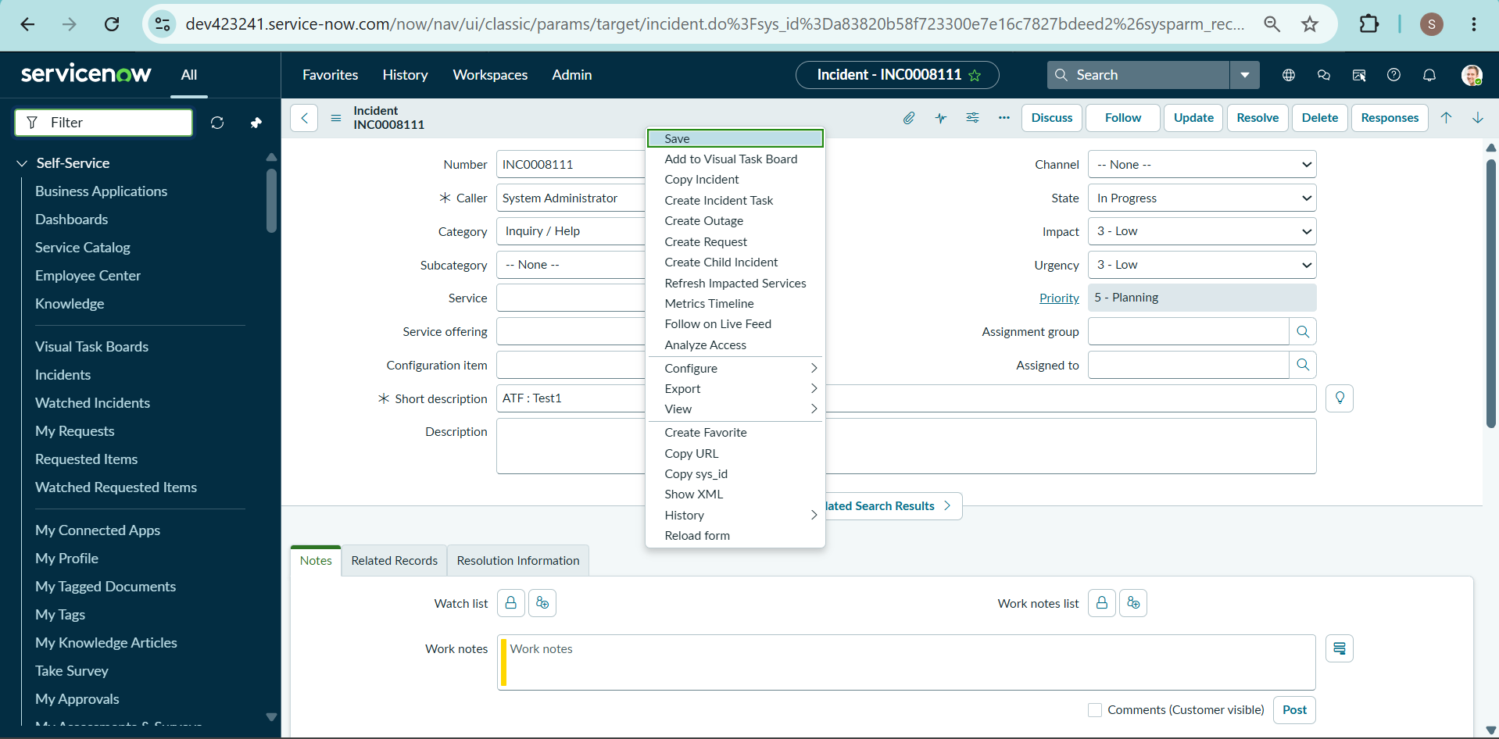
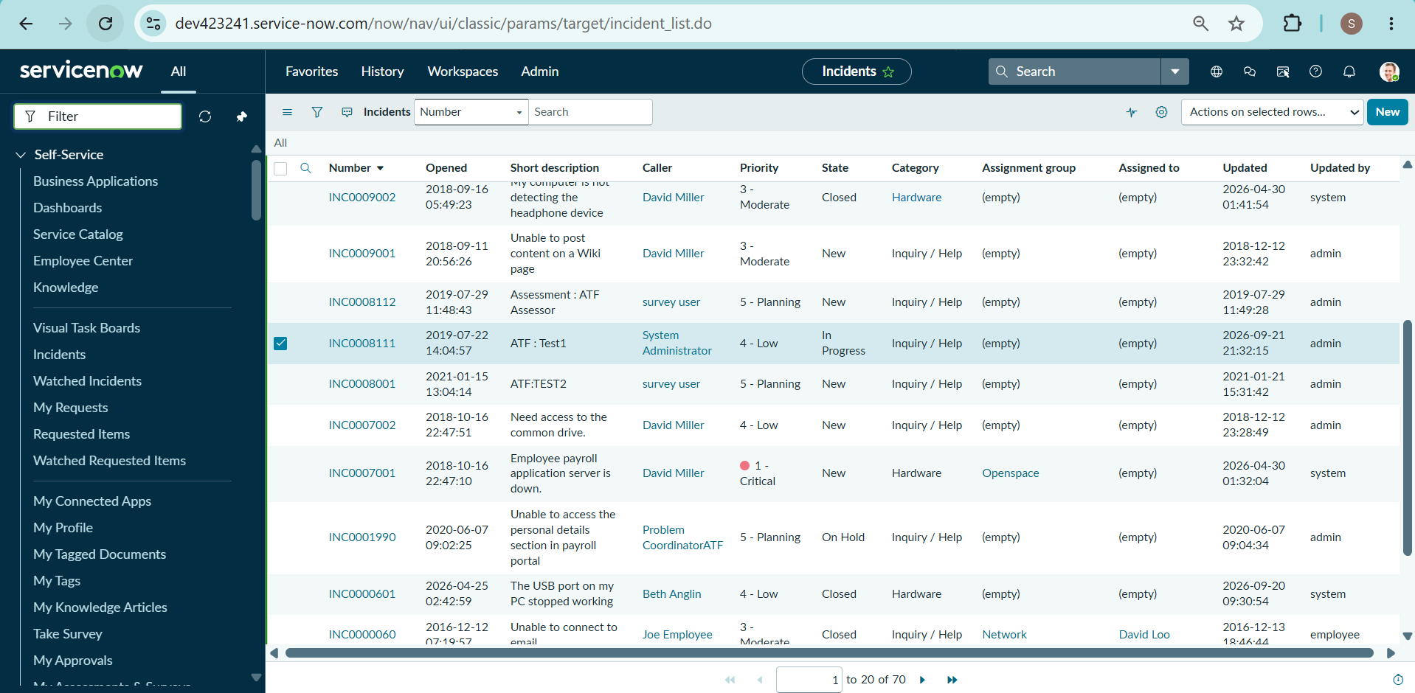

7.6 Testing Summary
The project was tested using different Incident scenarios to verify the configured UI Policy, UI Policy Action, onChange Client Script, onSubmit Client Script, and onCellEdit Client Script. The testing confirmed that the configured field Behaviour, validation, automatic value update, and State editing restriction worked as intended.

8. PROJECT DOCUMENTATION PHASE

8.1 Project Documentation
The project documentation was prepared to record the complete implementation and testing process of “Implement Client Script & UI Policy (Incident)” in ServiceNow.
The documentation includes the project requirements, design, planning, development activities, testing activities, screenshots, and final results.

8.2 Documentation Contents
The following activities were documented:
- Project problem identification
- Project objective and proposed solution
- Functional and software requirements
- UI Policy design
- UI Policy Action configuration
- Client Script configuration
- onChange Client Script implementation
- onSubmit Client Script implementation
- onCellEdit Client Script implementation
- Functional testing and verification
- Screenshots of important configurations and results
- Final project outcome

8.3 Screenshots and Evidence
Screenshots were captured during the project implementation and testing to provide evidence of the completed tasks.
The main screenshots include:
- High Impact Control – UI Policy
- Urgency – UI Policy Action
- onChange Client Script
- Automatic Urgency Testing
- onSubmit Client Script
- Prevent Save Testing
- onCellEdit Client Script
- State List Edit Restriction Testing
- Reverse Condition Testing
- State Form Update Testing

8.4 Final Documentation
All the implementation steps and testing results were organized into the project documentation. The screenshots were placed alongside the relevant tasks to clearly show the configuration and working results.
The completed documentation provides a record of the project from planning to implementation and testing.

8.5 Documentation Outcome
The documentation successfully records the implementation of UI Policies and Client Scripts for the Incident table and provides evidence of the testing activities performed during the project.

9. PROJECT DEMONSTRATION PHASE

9.1 Project Demonstration
The completed “Implement Client Script & UI Policy (Incident)” project was demonstrated in the ServiceNow environment. The demonstration explains the purpose of the project, the configured UI Policies and Client Scripts, their working process, and the final testing results.

9.2 Demonstration Content
The project demonstration includes the following:
- Project Name: Implement Client Script & UI Policy (Incident)
- Purpose of the Project: To improve data accuracy and control Incident form Behaviour.
- UI Policy: High Impact Control
- UI Policy Action: Make Urgency read-only for High Impact Incidents.
- onChange Client Script: Automatically set Urgency to High.
- onSubmit Client Script: Prevent saving when Assigned To is missing.
- onCellEdit Client Script: Prevent State changes through list editing.
- Testing: Verification of all configured rules using different Incident scenarios.
- Final Output: Successful implementation and testing of the required Incident controls.

9.3 Demonstration Process
The demonstration follows the project workflow:
Incident Form → Impact = High → UI Policy & Client Scripts → Field Control → Validation → Testing → Final Result
The screen recording shows the actual ServiceNow configuration and execution of the project. A voice-over is used to explain the purpose, implementation steps, working process, and results.

9.4 Final Demonstration Result
The demonstration shows that the configured UI Policies and Client Scripts perform the required Incident field controls and validations. The completed project was tested using the specified scenarios and the results were documented with screenshots.

10. CONCLUSION
The “Implement Client Script & UI Policy (Incident)” project demonstrates how ServiceNow UI Policies and Client Scripts can be used to control Incident records. The project implements dynamic field Behaviour, automatic value updates, validation during submission, and restrictions on direct list editing.
The project was developed and tested through different Incident scenarios. The testing confirmed the configured functionality and provided a practical demonstration of using client-side controls in ServiceNow Incident Management.

REFERENCES
- ServiceNow Developer Platform – ServiceNow platform and Personal Developer Instance environment used for project implementation.
- ServiceNow Incident Management – Used for creating, updating, and testing Incident records.
- ServiceNow UI Policies – Used to control Incident form fields based on conditions.
- ServiceNow UI Policy Actions – Used to configure field Behaviour such as read-only and mandatory settings.
- ServiceNow Client Scripts – Used for onChange, onSubmit, and onCellEdit client-side Behaviour.
- SmartBridge Project Document – “Implement Client Script & UI Policy (Incident)” – Used as the primary project guide for requirements, tasks, implementation, and testing.

